Redux Step by Step Set Up and Usage Document

# Pre-requisite [Install Redux using the following command]:

npm i redux react-redux redux-thunk

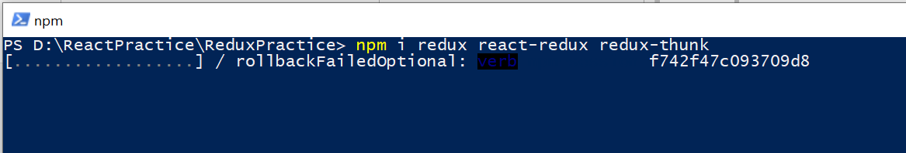

# Step 1: [Create Store Under src folder]

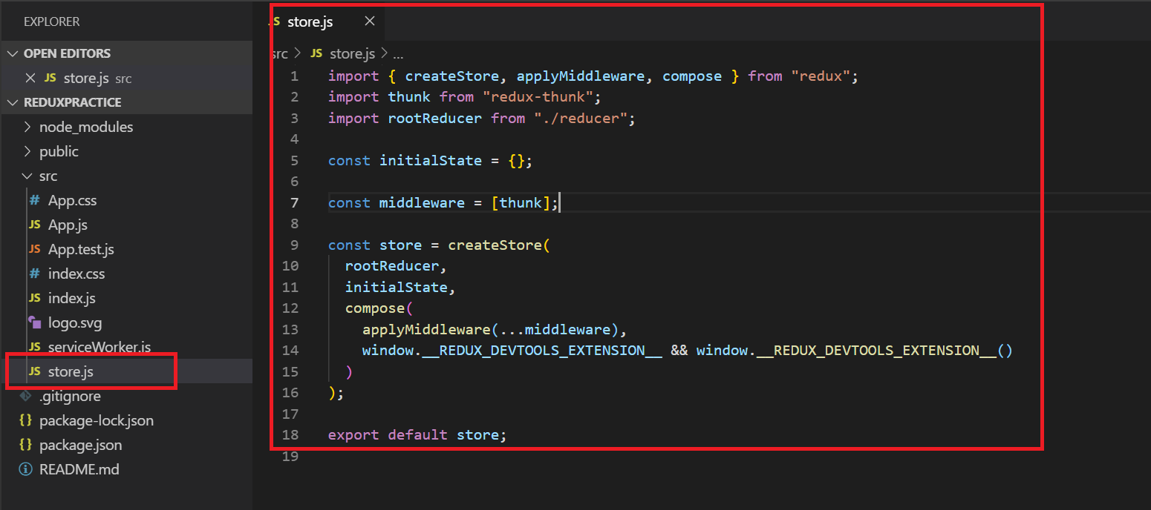

Copy of Store.js file



# Step 2: [Adding a Reference of store in App.js file]:

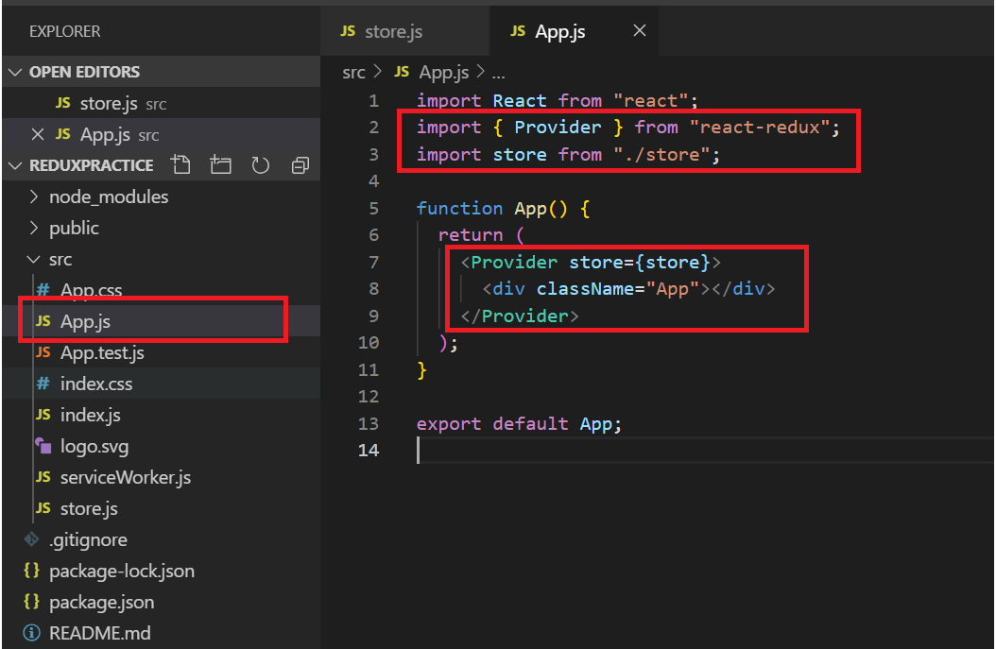

# Step 3: [Create ‘actions’ folder and add ‘types.js’ file in it]

**POINT TO REMEMBER**:

* What ever contents that we add here in this “types.js” file are the “Types” of the actions that we wanted to happen with in the application that we are going to create
* For example: Delete_contact, Add_ contact, Get_Contacts

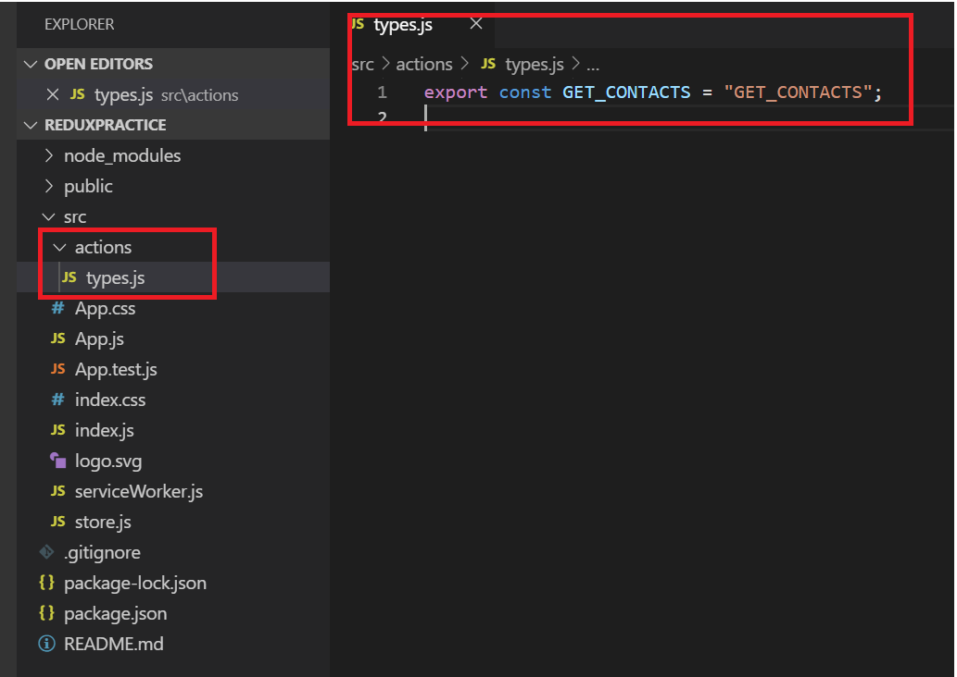

# Step 4: [Create an action file, which would contain the function/functions]:

**POINT TO REMEMBER:**  Action.js file can contain multiple function, but each function can be mapped or can call only ONE ACTION

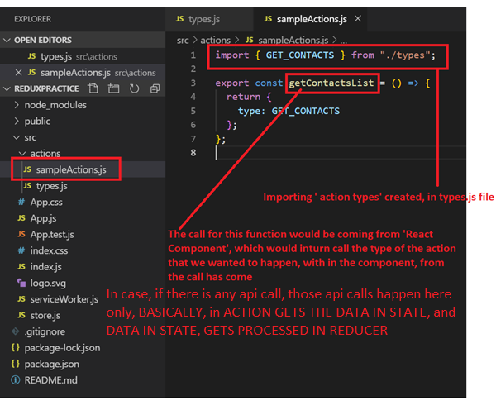

# Step 5: [create‘reducer’ folder and add ‘action type’ specific reducer js file ]:

**POINT TO REMEMBER**: Reducer.js file can contain only one “**default function**”, which takes, “state & action” as parameters

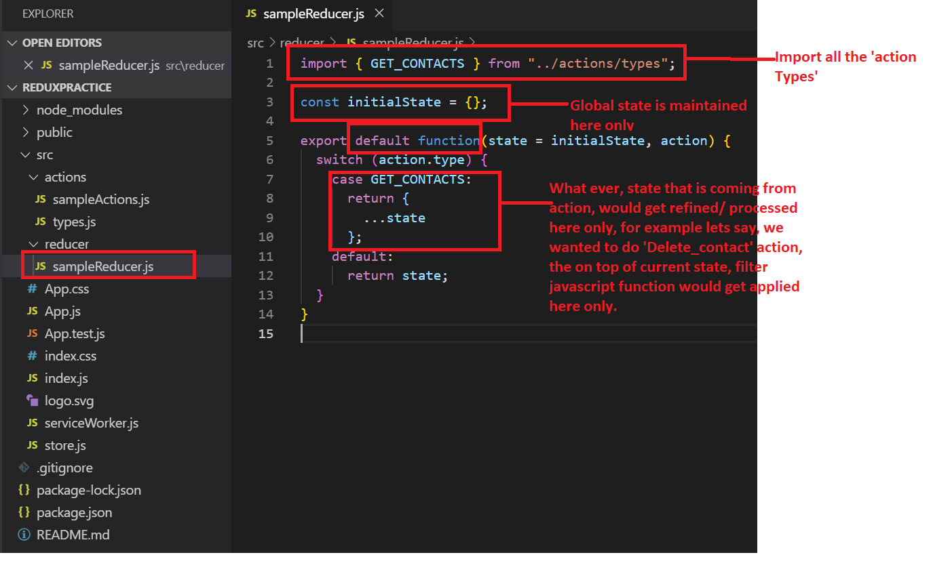

# STEP 6: [create ‘**index.js**’ file in the reducer folder, which would contain collation of all the reducers created in the application]:

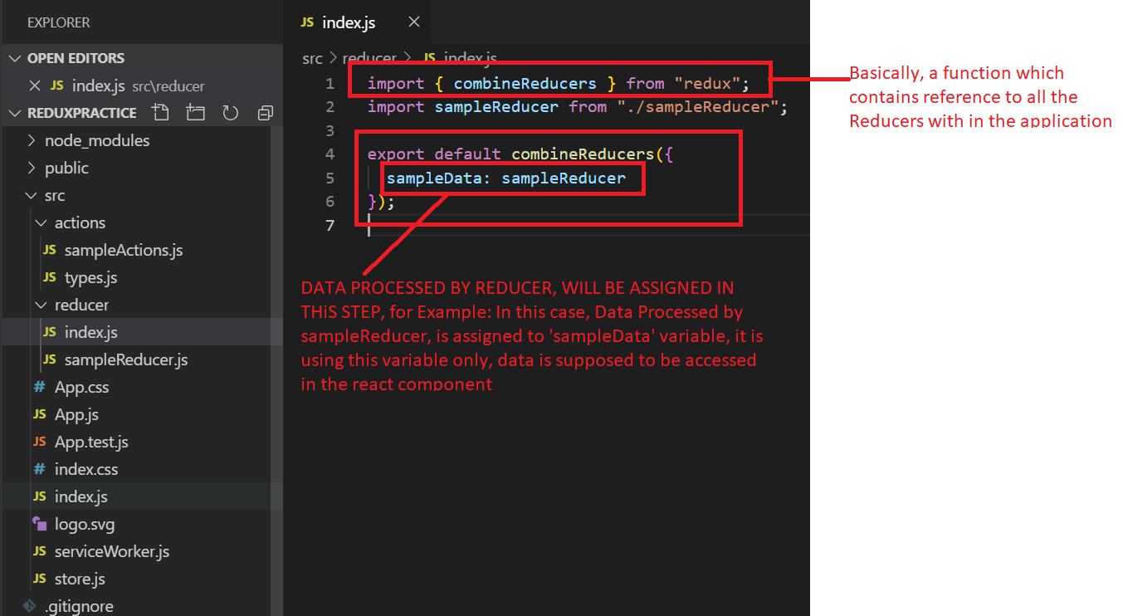

# Step 7: [Create Component and use actions/reducers in the component]:

